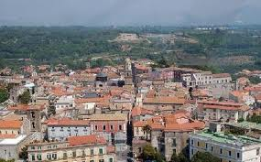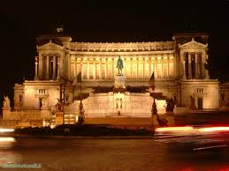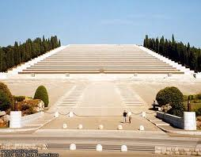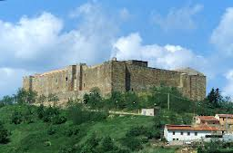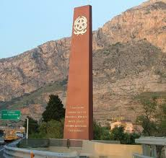MATCH THE PHOTO OF THE LANDMARK TO THE COUNTRY

Teano  
a. Turkey  
 b. Romania  
 **c. Italy** d. Poland

Monument to the King, Rome  
a. Bulgaria  
 **b. Italy** c. Romania d. Poland

War Cemetery, Redipuglia

**a. Italy**  
 b. Romania  
 c. Poland  
 d. Bulgaria

Lagopesole Castle  
a. Turkey  
 b. Romania  
 **c. Italy** d. Poland

Capaci massacre monument

a. Bulgaria  
 b. Poland c. Romania **d. Italy**